Semester Antara PBO

Nama Kelompok :

-Habibu Riski A11.2020.12807

-Hanna Herwida Oktavia A11.2020.13133

Tugas 1

1. Gambar diagram class

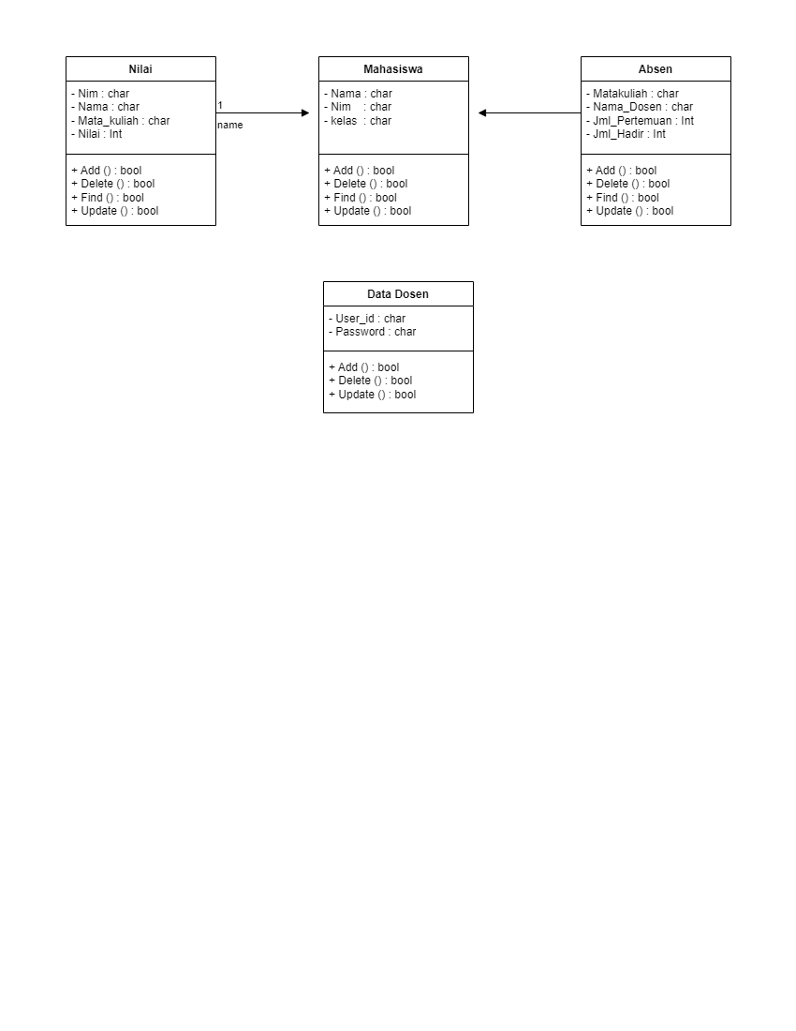

1. Definisi Class

: Nilai , Absen, Data Dosen

1. Penerapan encasulation (getter,setter)

**function setNilai ($x) {**

**$this ->nilai=$x**

**}**

**function setAbsen ($x) {**

**$this ->absen=$x**

**}**

**function setDataDosen ($x) {**

**$this ->datadosen=$x**

**}**

**function getNilai() {**

**return $this ->nilai;**

**}**

**function getAbsen() {**

**return $this ->absen;**

**}**

**function getDataDosen() {**

**return $this ->datadosen;**

**}**

1. Tambahan Constructor

**//constructor**

**public mahasiswa(String nilai, String absen, String datadosen ) {**

**this.nilai = nilai;**

**this.absen = absen;**

**this.datadosen = datadosen;**

}

1. Sub class dari Mahasiswa adalah Habibur